Workflow Audit

Task | Classification | One-line Rationale
Studying ASP.NET | Collaborate with AI | AI explains difficult topics and helps me understand concepts while I practice coding.
Update LinkedIn | Delegate to AI with Review | AI drafts posts and profile updates, and I review them before publishing.
Revise university lectures | Collaborate with AI | AI quizzes me and explains topics I don't fully understand.
Build backend projects | Collaborate with AI | AI suggests architecture, best practices, and helps with debugging.
Writing notes | Just Me | Writing notes myself helps me retain information better.
Preparing for exams | Collaborate with AI | AI creates quizzes and practice questions to test my understanding.
Update my CV | Delegate to AI with Review | AI improves wording and formatting, and I verify all information.
Go to the gym | Just Me | Physical exercise must be done by me.
Prepare my diet plan | Delegate to AI with Review | AI suggests meal plans, but I adjust them based on my needs.
Play padel | Just Me | Personal physical activity cannot be delegated.
Go out with my friends | Just Me | Building personal relationships requires my presence.
Organize family gatherings | Just Me | Family interactions require personal involvement.
Organize my study schedule | Just Me | I decide my priorities and available study time.
Plan next week's goals | Just Me | Setting my goals requires my own judgment and priorities.
Review previous week's progress | Just Me | Reflecting on my performance is a personal evaluation task.

Three Target Tasks and Success Criteria

Task | Classification | Success Criteria ("Done" means...)
Studying ASP.NET | Collaborate with AI | I understand the topic well enough to explain it in my own words, complete the related coding exercises, and build a working example without relying entirely on AI.
Revise University Lectures | Collaborate with AI | AI generates practice questions, and I correctly answer at least 80% of them without looking at my notes.
Build Backend Projects | Collaborate with AI | The project is completed with all planned features working, follows clean architecture principles, and I understand every part of the code before pushing it to GitHub.

AI tools
Chat gpt:
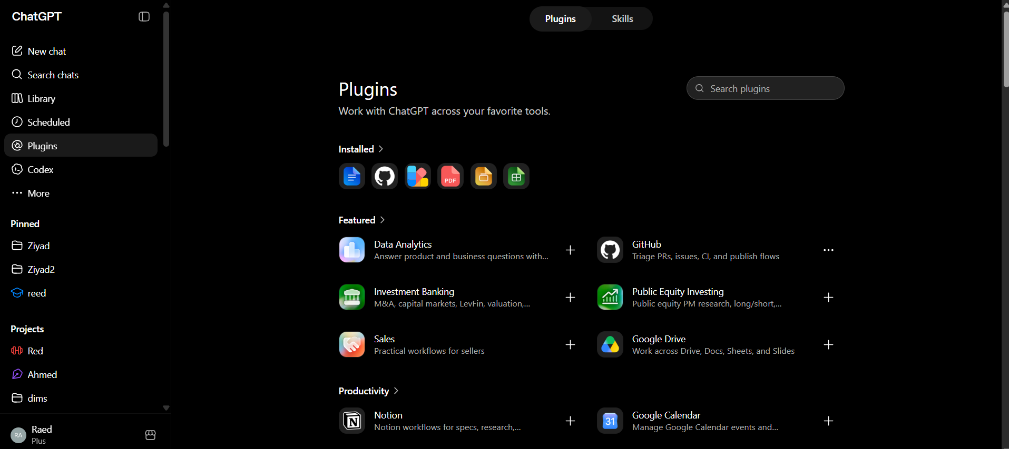
Gemini:
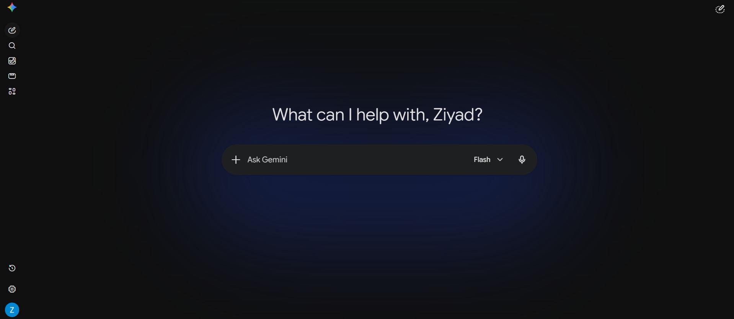

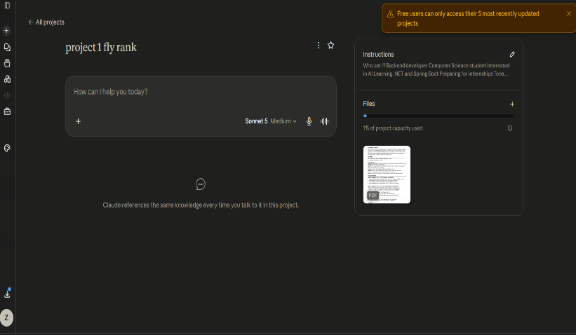
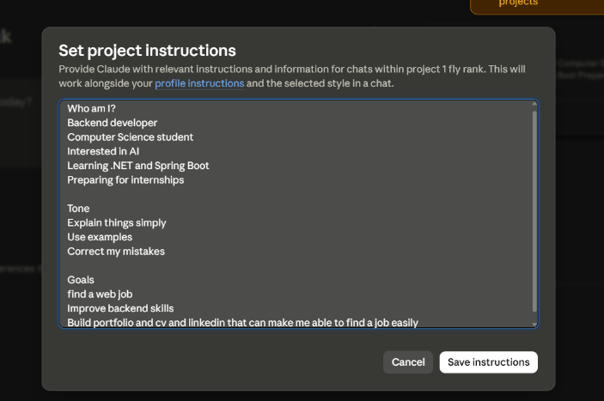
Claude:

Anthropic academy:
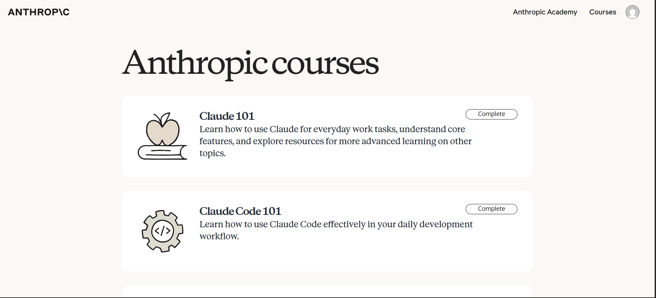

AI Fluency: Framework & Foundations:
